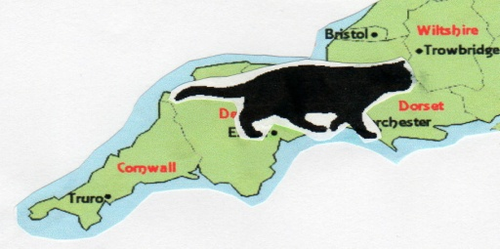
South West British Shorthair Cat Club
Affiliated to the Governing Council of the Cat Fancy

We are delighted to invite you to join the South West British Shorthair Cat Club.

To apply please send this completed form with your initial membership fee to:

Monica Acton, Membership Secretary SWBSCC, The Old Malthouse, Bagshot Road,
Fox Corner, Worplesdon, Guildford, GU3 3PT

(NB. if you have no email address please include a stamped addressed envelope for us to send you confirmation of the

committee’s acceptance of your application. Please tick the box below if you are happy for us to include your details in our membership records and for us to contact you via email or by post with information regarding club activities )

As a member you will have the opportunity to meet people with an interest in and love for British Shorthair cats and to join in our club events throughout the year.

Renewal subscriptions are due on 1st January each year (£5 single, £7 joint, £1 Junior)
(Please make cheques payable to South West British Shorthair Cat Club or pay by bank transfer to
Sort Code: 30-19-57 Account No: 00692696)
I/We* wish to join the South West British Shorthair Cat Club and agree to abide by the club rules and the constitution of the Governing Council of the Cat Fancy.
NAME:____________________________________________________________________
ADDRESS: ________________________________________________________________
__________________________________________________________________________
TEL: _________________________________Email:_____________________________________
I/We are interested in breeding / showing and have the following Pedigree / Household pets.

(Please specify breeds and breed numbers)
___________________________________________________________________________
___________________________________________________________________________
___________________________________________________________________________
PREFIX (If you have one) _____________________________Date____________________

Name and Signature of Introducing Member ______________________________

For Office use only:

Committee Approved_____________________ Date ______________________

